Artist Studio Space
Open in March, 2018: second floor studio space for artist:
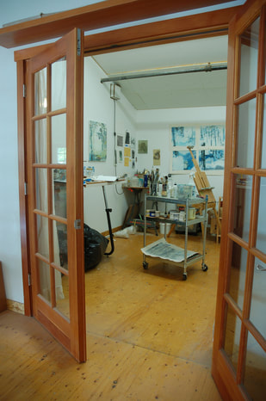
Studio Space 150 SF 12' x 12' cost: $400
Great location, Newer Capitol Hill Building with other artists and custom woodworkers.
no lease, no deposit
Rent Includes:
Internet access
Kitchenette
24 hour access
All utilities and other costs included
Sorry, no live ins
​email Hank at: hank@holzerames.com
or call 206-403-3589 or 206 324-8538
www.wisteriadesigngroup.com

